# ELECTRIC CIRCUITS

# HOMEWORK-I

**Due Date: December 2, 2013**

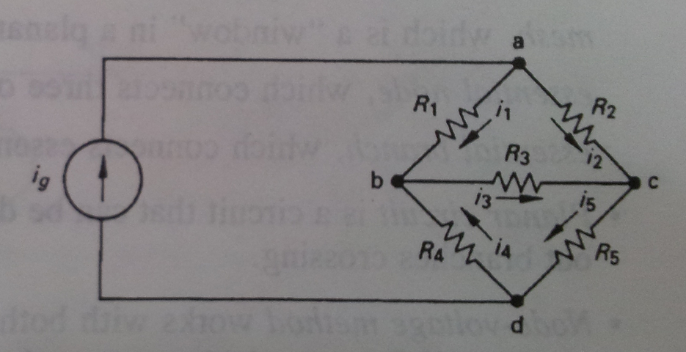1. Assume that the current ig in the circuit is known. The resistors R1 through R5, are also known.

1. How many unknown currents are there?
2. How many independent equations can be written using Kirchhoff's current law?
3. Write an independent set of KCL equations.
4. How many independent equations must be derived from Kirchhoff's voltage law?
5. Write a set of independent KVL equations.

2. a) Use the node voltage method to find the branch currents i1, i2, i3 in the circuit.

b) Check your solution for i1, i2, and i3 by showing that the power dissipated in the circuit equals the power developed.

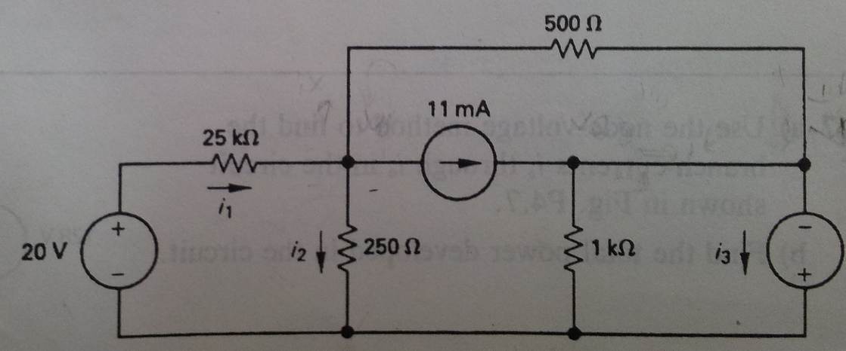

3. The voltmeter shown in Fig a has a full scale reading of 750 V. The meter movement is rated at 75 mV and 1.5 mA. What is the percent error in the meter reading if it is used to measure the voltage v in the circuit of Fig b.

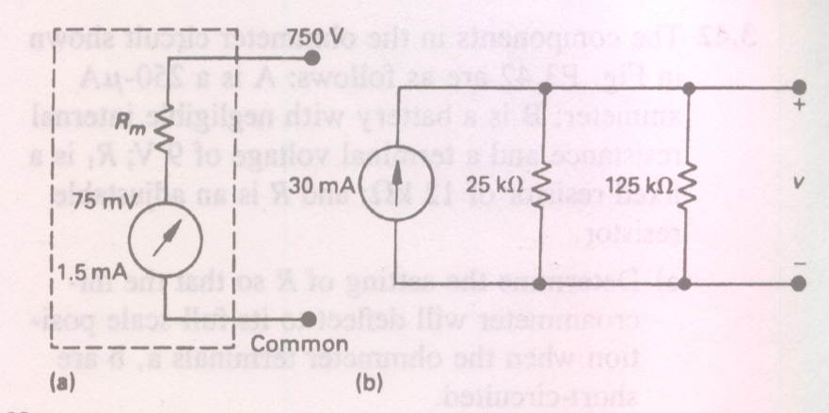

4. a) Find the branch currents ia through ie for the circuit shown below.

b) Check your answers by showing that the total power generated equals the total power dissipated.

